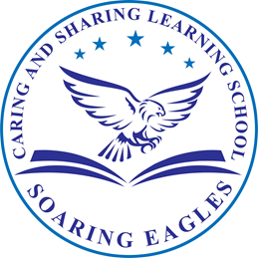

CARING and SHARING LEARNING SCHOOL ENROLLMENT POLICY

CSLS admits students without regard to ethnicity, national origin, gender or disability. In accordance with current state law on admission to charter schools, preference may be given to siblings of students already enrolled in the school, children of staff or of members of the Board of Directors and shall be given to residents of Alachua County. There is a lottery procedure used under certain circumstances which takes into account the residency of the students seeking enrollment.

CSLS abides by anti- discrimination provisions 1000.05 F.S. which forbids discrimination on the basis of race, nationality, origin, sex, handicap or marital status, against any student or an employee in a state system of public education. Every student who registers for enrollment in CSLS does so on a voluntary basis and the school will accept all students until a maximum capacity is reached or a random lottery drawing determines the student population. If the number of prospective students for admissions exceeds the school's capacity, a lottery system is used to provide applicants an equal chance of being admitted through a random selection process.

If on March 1 of each year there are more local applicants than there are spaces in a given grade, a lottery is held among local applicants only. Otherwise, spaces are given to local applicants first and a lottery is held if needed among non-local applicants. Applicants who are not admitted are assigned to a waiting list according to the same lottery. New students may be admitted on the basis of the existing waiting list and their residency.

